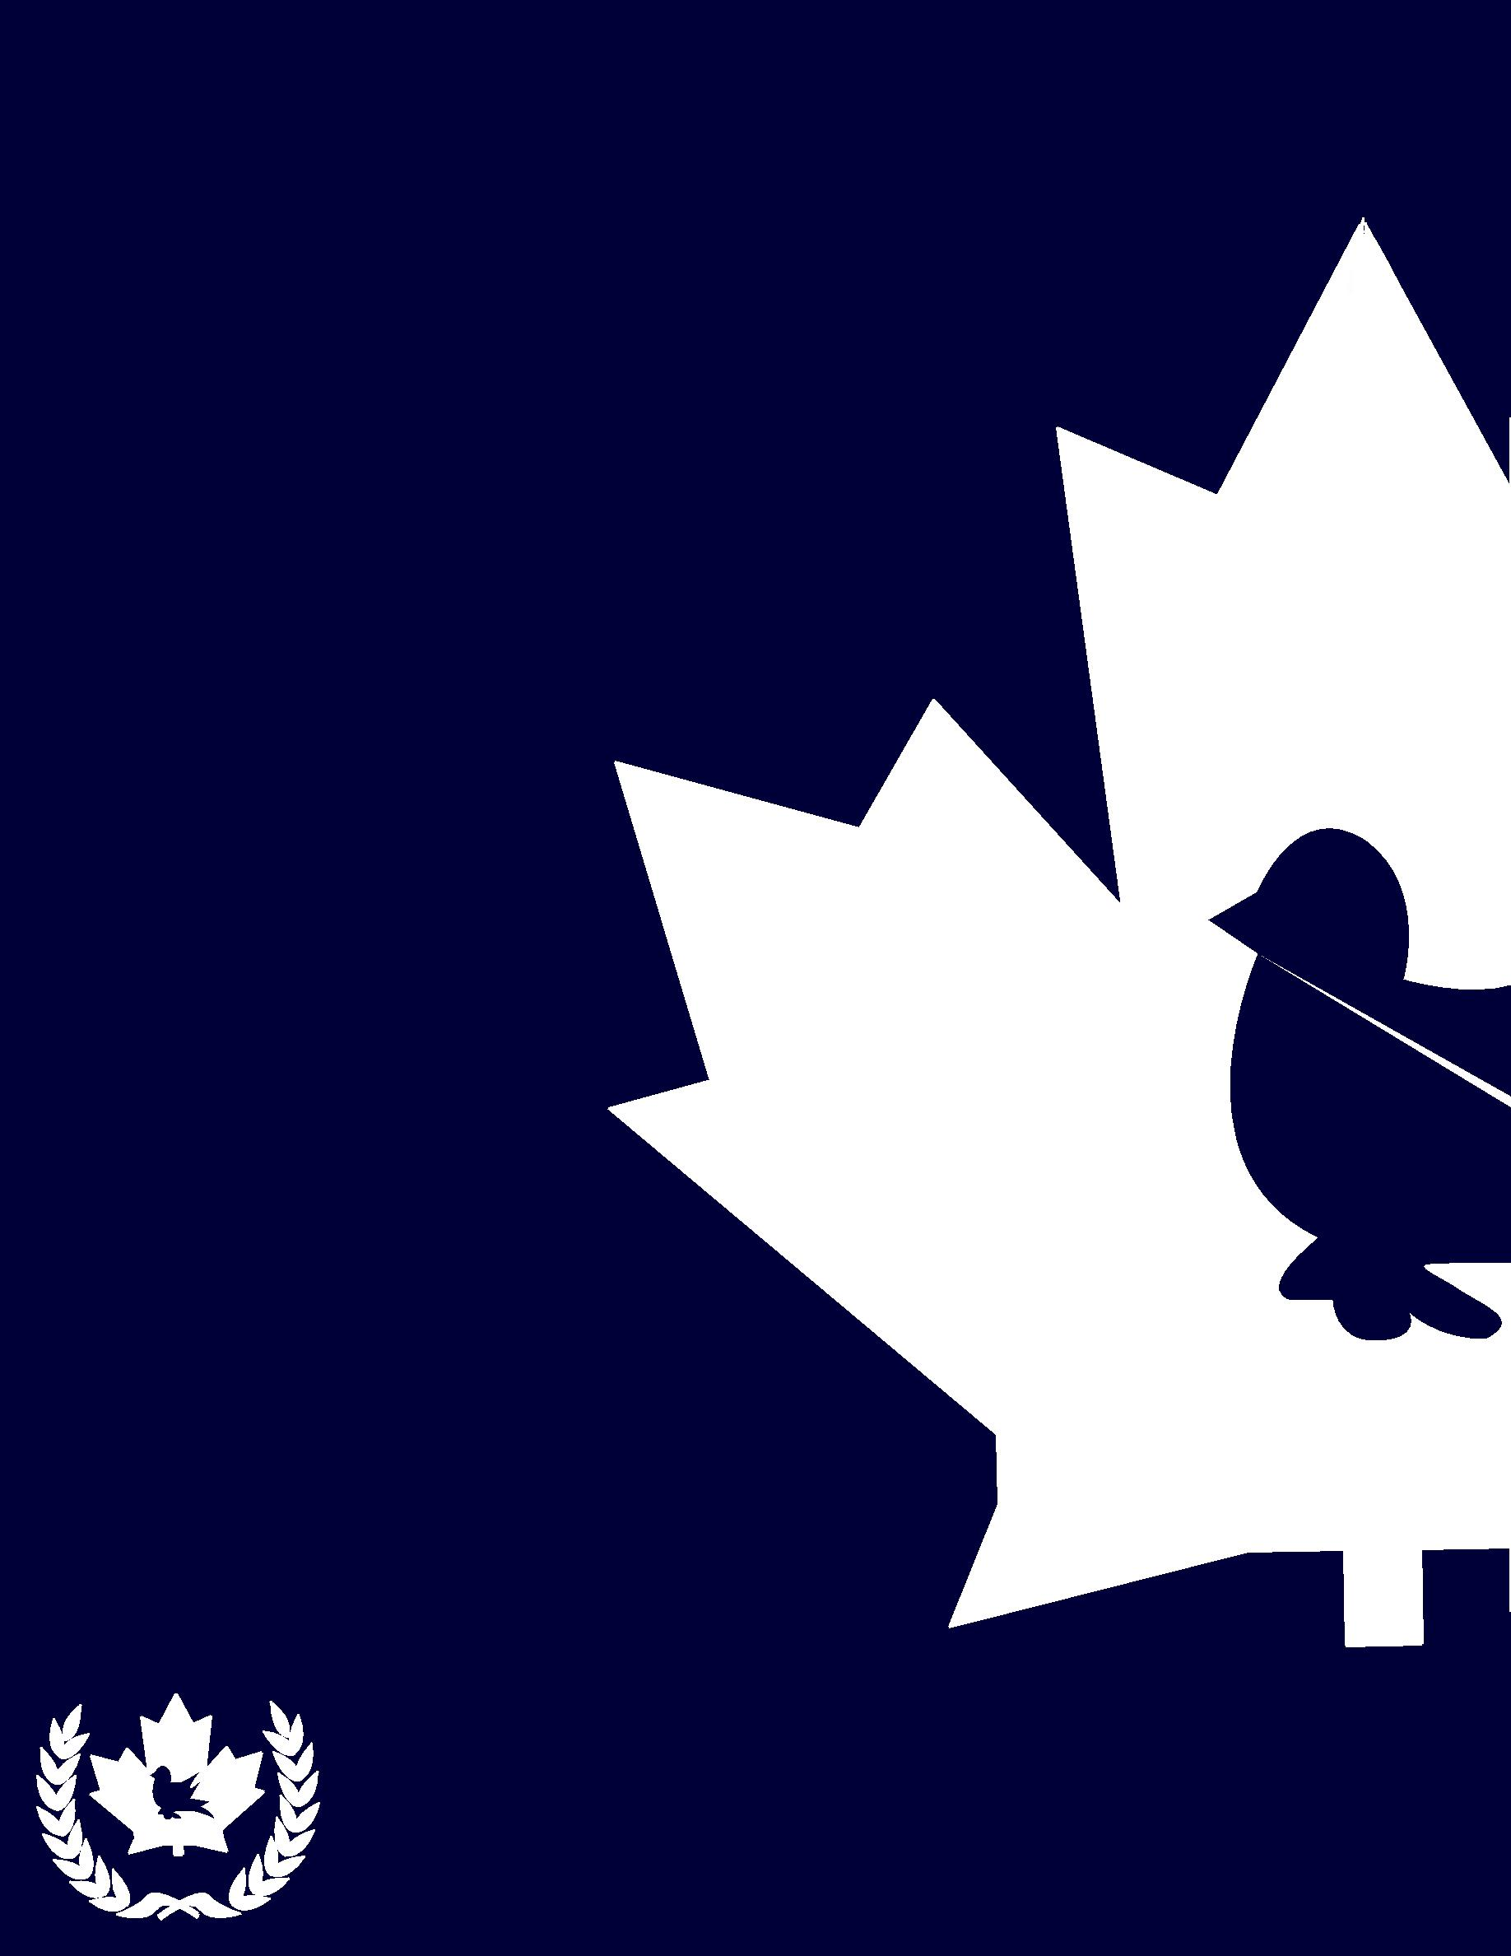SECONDARY SCHOOLS’ UNITED NATIONS SYMPOSIUM 2016

Canadian

Confederation

Chair:

Jesse Hartery

Vice Chairs:

Danielle Medlej

Marian Daubouil

Yulia Yugay

NOVEMBER 10-13, 2016 | MONTRÉAL, QUÉBEC

Chers/Chères délégué(e)(s),

J’aimerais d’abord vous souhaiter la bienvenue au comité bilingue « Canadian Confederation » de la Conférence SSUNS 2016. Chacun d’entre vous aura la chance de faire le point sur les enjeux qui ont fait l’objet de débats intenses en 1864, soit à la Conférence de Charlottetown et de Québec. Vous allez avoir le grand défi de créer un nouveau pays. Pour ce faire, vous allez devoir compromettre avec les délégués des autres colonies présents à la Conférence, tout en assurant de protéger les intérêts de votre région. Notre comité débutera le 1er septembre 1864, soit le premier jour de la Conférence de Charlottetown, dans le but de vous donner la chance de prendre en compte les nombreuses options disponibles dans la création de ce nouveau pays : l’union des colonies maritimes, une union fédérale plus vaste ou la création d’un État unitaire.

I have the privilege to work with three incredible vice chairs to prepare this committee. They have put an enormous amount of work into making this experience one to remember and I am extremely thankful for their continued enthusiasm.

Let me start by introducing Daniele Medlej, who recently graduated with a Bachelor’s degree in Political Science and Sociology and will be pursuing a Master’s in Political Management following a gap year. She has been involved in MUN since high school and has represented McGill at several MUN conferences throughout Canada and the U.S. This summer, she also did an internship in the office of Prime Minister Justin Trudeau. In her free time, she loves traveling, playing piano and watching anything Netflix suggests.

Our next vice chair, Marian Daubioul, is a second year student pursuing a joint honours in Political Science and History. Born in France, but a Canadian at heart, his first encounter with MUN was at McGill. So far, he has done everything from GAs to Crisis Committees at Boston University, Harvard University, l’Université de Montréal, McMUN and others, both as a staffer and as a delegate. When not preparing or participating in a simulation, he lives the life of a hermit and usually hides behind a good book.

Our third vice chair, Yulia Yugay, is a first year law student. Originally from Kazakhstan, she was first introduced to Model UN in CÉGEP, where her MUN journey began. Last year, she attended SSUNS 2015 as a delegate in the Bilingual Committee and won the Nelly McClung Award for Advocacy, which makes this her first experience as a SSUNS staffer. She is passionate about animal rights, loves traveling and plays the piano.

Finally, a little about myself. I am currently a second year law student at McGill. I previously earned an Honours B.A. in History with a minor in Asian Studies from the University of Ottawa. Moreover, I had the distinct opportunity to work in federal politics for the late Jim Flaherty and former Prime Minister Stephen Harper before settling in at McGill in September 2015. I was introduced to MUN in high school at l’École secondaire publique Gisèle-Lalonde and had the opportunity to attend SSUNS three times as a delegate. Last year, I was the Opening and Closing Ceremonies Coordinator for SSUNS and am so happy to be involved once again. In my spare time, I teach martial arts and do my part to advance LGBT rights.

I want to encourage all of you to truly understand the various issues faced by British North American politicians during the 1860s. I hope your research and the debates you will have during this Conference illustrate what makes Canada such a wonderful country. As Theodore Roosevelt once said: “Nothing in the world is worth having or worth doing unless it means effort, pain, difficulty”. All these elements will characterize your discussions, but I hope that your experience will have been fruitful and exciting. I know I am doing my best to make sure that is the case.

Added to this, our committee is partnering with the Peter MacKell Chair in Federalism to offer one of you a scholarship. On top of drafting your position papers, you will have the opportunity to write a short opinion piece about modern Canadian federalism that could earn you the MacKell Chair Prize worth $200. Dr. Johanne Poirier, the inaugural holder of the Peter MacKell Chair in Federalism and a constitutional law professor at McGill, will be awarding the prize to the best entry.

Please do not hesitate to contact me at [jesse.hartery@mail.mcgill.ca](mailto:jesse.hartery@mail.mcgill.ca) should you have any questions regarding the background guide or the Conference in general. It would be a pleasure for me to answer your questions.

Nous avons extrêmement hâte de vous rencontrer en novembre !

Cordialement,

Jesse Hartery

Chair, Canadian Confederation

SSUNS 2016

**Topic 1: Institutional Design and Regional Diversity**

**Political Institutions After the British Conquest**

British North America has been through many institutional changes since the British Conquest of New France. In 1763, King George III promulgated the *Royal Proclamation* which promised to establish legislative assemblies in the newly conquered colonies. More importantly, it was agreed that English law would replace the existing French legal system in the former New France. The legislative assembly was never established given the fact that the French population in the region largely outnumbered the English-speaking population at the time.[1] The British Parliament laid out these changes permanently in the *Quebec Act* of 1774 by providing for an appointed legislative council instead of an elected assembly. Added to this, French law was restored for private law matters, while English law continued to govern criminal cases, and freedom of religion was ensured for Roman Catholics, meaning they could now accept seats on the legislative council.[2]

Dissatisfaction with the *Quebec Act* grew, largely due to the influx of British Loyalists after the American War of Independence, and Britain was forced to adopt the *Constitutional Act* of 1791, which divided Quebec into two colonies, Upper and Lower Canada. Each colony had a lieutenant-governor and a bicameral legislative structure composed of an appointed Legislative 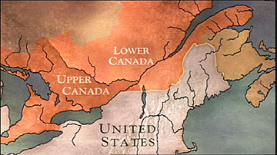Council (modelled on the British House of Lords) and an elected assembly (modelled on the British House of Commons)[3]. This meant Lower Canada could maintain its civil law system, while Upper Canada was free to revert to the British legal system. The governor was also to be advised by an Executive Council of his choosing and together they exercised significant powers, without being accountable to the legislative branch of government.[4]

*Figure 1: British North America before the Union Act*

**Modern Parliamentary Institutions and Responsible Government**

After years of dissatisfaction with the lack of democratic accountability in the colonies, rebellions sprung up in Upper and Lower Canada in 1837, before being quickly suppressed by British authorities. In 1839, the British government appointed Lord Durham to study the political changes in the colonies and report back. He made two key recommendations to the Imperial Parliament: 1) the implementation of responsible government in the colonies; and 2) the union of Upper and Lower Canada into a single province.[5]

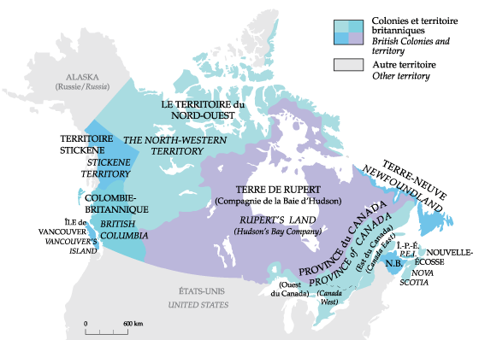En 1840, le Parlement britannique adopta l’*Acte d’Union*. On ne faisait désormais plus la distinction entre le Bas-Canada et le Haut-Canada puisqu’ils ont été unifiés en une seule Province du Canada[6]. Cet Acte fut le résultat direct du rapport de Lord Durham et eut deux objectifs principaux :

*Figure 2: British North America post-Union Act*

1. Culturellement : assimiler les Canadiens-français à la population protestante anglophone croissante afin que la majorité anglophone garantisse la fidélité de la Province au Royaume-Uni;
2. Économiquement : assurer la solvabilité du Haut-Canada, considérablement endetté, en le joignant au Bas-Canada qui connaissait sa période de prospérité.

Quoique l’*Acte d’Union* visait principalement à unifier les Canadas, il restait néanmoins une distinction importante entre le Canada-Ouest (majoritairement anglophone) et le Canada-Est (majoritairement francophone). Plus précisément, ce nouveau système faisait en sorte que chacune des deux régions obtienne 42 sièges (65 sièges dès 1854) dans l’Assemblée législative (élu depuis 1841) et 24 sièges dans le Conseil législatif (nommé, mais élu après 1856) dans le but de maintenir l’équité régionale. Cependant, la population du Canada-Est considérait que ce système était injuste étant donné que l’anglais fut la seule langue officielle de l’Assemblée[7].

As of 1842, a noticeable shift occurred when the governor appointed an Executive Council headed by Robert Baldwin and Louis-Hippolyte Lafontaine, two proponents of responsible government. Responsible government has two key pillars: the first being that the Executive Council must be composed of people who have the confidence of the legislative assembly, without which they would be forced to resign; the second being that the governors are bound to follow the advice of the members of the Executive Council – something that had previously not been mandatory.[8] Nova Scotia was in fact the first colony to fully adopt the model in early 1848. In the Province of Canada, then-governor general Lord Elgin is credited with solidifying responsible government by giving his assent to a bill meant to compensate Canadians who had suffered losses during the rebellions, despite being against the measure himself[9]. While the legal structure adopted in the *Union Act* did not change, a constitutional convention emerged that saw the actions of the governor significantly limited.[10] This model spread to the other British North American colonies: Prince Edward Island in 1851, New Brunswick in 1854 and Newfoundland in 1855.[11]

**The Problems with the Union Act**

L’amendement concernant la représentation proportionnelle à la population (en anglais : « *rep by pop* ») ne fut jamais inclus dans l’*Acte d’Union*. Donc, en ayant un nombre égal de représentants pour le Canada-Est et le Canada-Ouest, la seule façon d’adopter une loi, en pratique, était d’avoir une double majorité. Autrement dit, les deux régions doivent tous deux voter en faveur de la loi afin que cette dernière soit passée par l’ensemble de l’Assemblée législative[12].

That said, Britain had agreed to amend the *Union Act* to make French an official language of the legislature as of 1848, thus reversing a policy that had been the cause of much opposition by French Canadians. In an effort to maintain cultural, religious and linguistic protections, French Canadians in Canada East were keen to make allies in Canada West, which they found in the Liberal-Conservative Party. As the idea of “French domination” made headway and other tensions became widespread, the need for constitutional change was front and centre. In 1864, the government led by Étienne-Paschal Taché and John A. Macdonald in the Province of Canada was defeated by a vote of non-confidence, before being saved by George Brown and his Reformers who sought to form a coalition government with the sole purpose of forming a union with other British North American colonies. This, in their opinion, would serve to remedy the deep divisions faced in the Province of Canada.[13]

**Maritime Union and Newfoundland’s Place in British North America**

In 1864, New Brunswick, Nova Scotia, and Prince Edward Island began considering forming a Maritime Union.[14] They intended to remain in the British Empire, while also getting together to pool their resources and increase their political capital and effectiveness. That said, they wanted to achieve this while also maintaining the political independence and local legitimacy of each colony.[15] The concept of a ‘Maritime Union’ is not new. Prince Edward Island and New Brunswick had once been administered by Nova Scotia during the eighteenth century. Furthermore, the British Colonial Office also favoured the union as a way to reduce colonial reliance on the mother country.[16]

While the Imperial Parliament allowed Newfoundland to establish responsible government in 1855, it was not obtained easily. It took years for Britain to relent, because the colony was not considered economically viable. Moreover, the colony relied heavily on imports and its revenue intake was dependent on the use of tariff barriers, meaning a potential free-trade zone through a unified colony would pose particular problems for Newfoundland.[17] As an island, it also has its own unique problems and seemed at odds with the vision of the other colonies, more specifically with regards to military preparedness and railway building. This led some to fear that Newfoundland would be saddled with taxes from a central government that would give it virtually no benefit.[18] As such, the Newfoundland delegates to the Conference were given observer status and had no mandate to approve measures on behalf of the Newfoundland government.[19]

**Executive, Legislative and Judicial Branches as of 1864**

Executive Authority, in all the colonies, is vested in Her Majesty Queen Victoria. That said, as mentioned above, executive powers are exercised by the governor (or lieutenant-governor) on the advice of his council of ministers.[20] While the governor used to attend council meetings until the mid-1850s, the council now meets separately and transmits its decision to the governor. Once the decisions are approved, they become actions of “the Governor-in-Council”.[21] The Premier (or Co-Premiers in the case of the Province of Canada) is considered *primus inter pares* (“first among equals”) in the Executive Council (also known as the Cabinet; in Britain, the Cabinet is considered a committee of the Privy Council). Generally, the governor will call on the leader(s) of the political party (or parties) with a majority of seats in the elected assembly to form a government. That leader will then suggest individuals for appointment to the Cabinet (while they are generally members of the legislature, they do not have to be). The government has a dual role: 1) to propose legislation for adoption by the legislature and 2) to execute the will of the legislature as defined in the laws it passes.[22]

Legislative Authority is vested in the legislature of each colony, which currently function as bicameral institutions. A bicameral legislature is defined as having two legislative chambers, which means a bill must be approved by both houses before it is sent to the governor for royal assent.[23] Once a bill receives royal assent, it becomes law.[24] Of note, “bills for appropriating any part of the surplus of the Consolidated Revenue Fund, or for imposing any new Tax or Impost” must originate in the Legislative Assembly after being introduced by the Cabinet.[25] Essentially, the budget must be introduced by the Cabinet in the elected lower house before it can proceed to the upper house.[26] At present, each colony is entitled to pass laws on any matter – something that would necessarily have to change if a federal union were chosen. Unless those laws conflict with a law applicable to the colonies adopted by the Imperial Parliament in Britain, they are considered valid.[27]

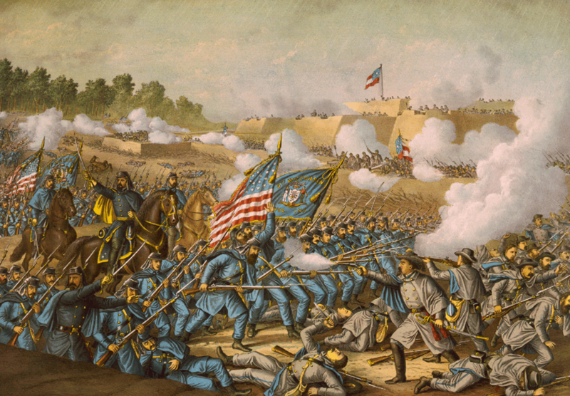 Judicial Authority is vested in the various courts of British North America (the highest being the superior courts and, in some cases, the courts of chancery in each colony).[28] These judges are appointed by the Governor-in-Council and hold office for life, unless they are removed by the governor following a vote from the legislature.[29] At the apex of these courts is the Judicial Committee of the Privy Council in Britain. After exhausting appeals in colonial courts, litigants are encouraged to seek remedies before the Queen-in-Council. In practice, British judges (the Judicial Committee of Her Majesty’s British Privy Council) offer the Queen advice through a legal ruling which, given the nature of governance in a democratic system, she accepts without question.[30]

**Case Study: United States of America**

Afin de déterminer la meilleure façon de séparer les compétences législatives au Canada, il est conseillé d’analyser l’exemple des États-Unis d’Amérique qui forment une fédération. Il est important de mentionner que les pouvoirs furent quand même bien décentralisés. En fait, les pouvoirs résiduaires (qui ne sont pas réservés au gouvernement central par la Constitution) furent alloués aux états par le biais du dixième amendement[31].

*Figure 3 : La bataille de Williamsburg entre les Unionistes et les Confédérés le 5 mai 1862*

Étant une nation où les pouvoirs sont pour la plupart répartis aux états plutôt qu’au gouvernement central, elle fit face à plusieurs défis. Un des plus importants d’entre eux fut le régionalisme. À cause du phénomène d’esclavage hautement controversé et très présent aux États-Unis dans les années 1800, il y eut de considérables conflits entre le nord et le sud du pays qui entrainèrent la guerre civile en 1861 (qui est toujours en cours)[32]. Par contre, la décentralisation des pouvoirs autorise le peuple à baliser les lois selon ses besoins.

En ce qui concerne la législature centrale, le Congrès bicaméral fut composé du Sénat, où chaque état fut représenté par deux Sénateurs élus, non par le peuple, mais par la législature des états, et par la Chambre des Représentants des citoyens qui sont élus par ces derniers[33]. Furthermore, at the apex of the judicial branch lies the Supreme Court, which is composed of judges who are first nominated by the President and then approved by the Senate. The Supreme Court has the authority to rule out legislation passed by the legislative branch or an act taken by the executive branch in cases it judges the act to be unconstitutional, which is referred to as judicial review.[34] In other words, the separation of powers into executive, legislative and judicial branches ensures oversight of each individual one.

**Case Study: Great Britain**

As opposed to the United States, Britain is a prime example of a unitary government. In other words, all the powers are by default assigned to the only (hence the name “unitary”) centralized government, which leaves no room for residual powers. Although the concept of checks and balances is a lot less present in the British unitary government, it suits the nation that shares a common identity.

*Figure 4: The House of Commons after the adoption of the 1832 Reform Act*

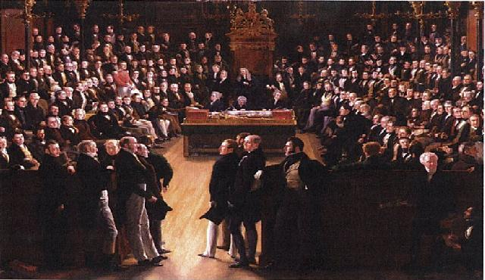 The British Parliament, which also is a bicameral legislative system, is composed of the House of Lords (Upper House) and the House of Commons (Lower House). In the former, the Lords are nominated by the Prime Minister, and are appointed by the Queen; while in the latter, the representatives are elected to represent the people.[35] Importantly, it is only after the Reform Act of 1832 that the way the members of the Lower House were chosen became fairer. Stated otherwise, prior to that year, the representation was disturbingly disproportionate and unbalanced.[36] Furthermore, although the appointment of the Lords may seem undemocratic, it allows for a diverse second chamber with members from diverse professional and political backgrounds. This enables the Upper House to objectively oversee the bills presented by the House of Commons, suggest amendments, and point out their flaws. Thus, for a bill to become a law, it requires the approval of both independent chambers after a series of readings and amendments.[37]

Quant au rôle des tribunaux au Royaume-Uni, il est loin d’être aussi étendu qu’aux États-Unis. Contrairement au contrôle judiciaire de la constitutionnalité, où le pouvoir judiciaire prévaut en quelque sorte sur la branche législative et exécutive, le Royaume-Uni est caractérisé par la souveraineté parlementaire. En d’autres termes, le Parlement a l’autorité législative que même son plus haut tribunal ne peut récuser. En revanche, les lois adoptées par les chambres parlementaires ne sont pas indélébiles et peuvent être modifiées par les gouvernements futurs[38].

**Questions to Consider:**

1. **Quel modèle de gouvernance est plus susceptible de promouvoir la diversité régionale ? Devrait-on avoir une union fédérale ou un État unitaire ?**
2. **Should British North America adopt a legislative union with representation by population to remedy the political problems inherent in the current system as established in the Province of Canada?**
3. **Les provinces de l’Atlantique devraient-elles se joindre à cette union ou risquent-elles d’être noyées par une surreprésentation du Canada-Ouest et du Canada-Est ? Comment peuvent-elles assurer leur survie politique ?**
4. **How should the executive, legislative and judicial branches be exercised in this new union?**
5. **What status should the French language have in the union of the provinces? Are French speakers and religious minorities afforded any rights?**

**Topic 2: Canada – A Staple Economy?**

Canada has traditionally been a ‘staple economy’, meaning its growth has been fuelled by the exploitation and export of natural resources. However, the Canadian economy is still stabilizing and finding its ground in a new era – which began when Great Britain abandoned its mercantile system, thus terminating its 200-year imperial preferences for Canadian goods.

Between 1842 and 1860, all differential duties were dispatched, with timber duties being the first to be affected[39]; in 1846, the Corn Laws were abolished[40], and the Irish famine of 1845-46 forced the free admittance of offshore wheat by the British Government[41]; British ports became open on equal terms to the vessels of all nations as the Navigation Acts were repealed in 1849 and 1854.[42] In short, Great Britain went from an estimated 1,150 duty-carrying goods in 1840 to fewer than 50 in 1860.[43]

However, and in spite of merchants’ anxiety, the Canadian industry did not suffer the downfall feared as inevitable with the abolishment of preferential tariffs. For example, its timber industry experienced major development as a growing share of its exports included processed products, of which the American market was fond, as opposed to squared timber. Agricultural production in the Province of Canada, as well, rose from 43.2 million CAD to 101.8 million CAD between 1851 and 1860.[44]

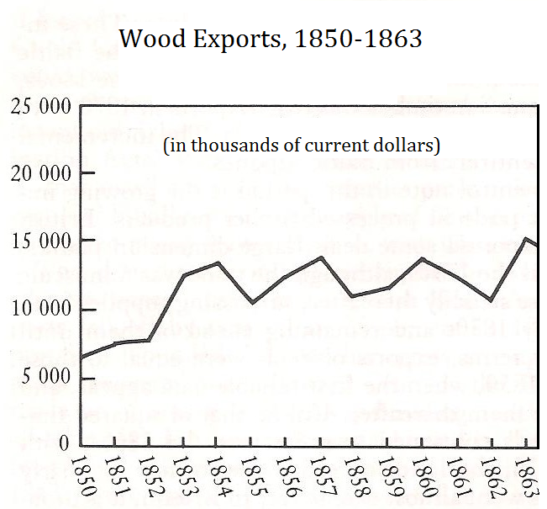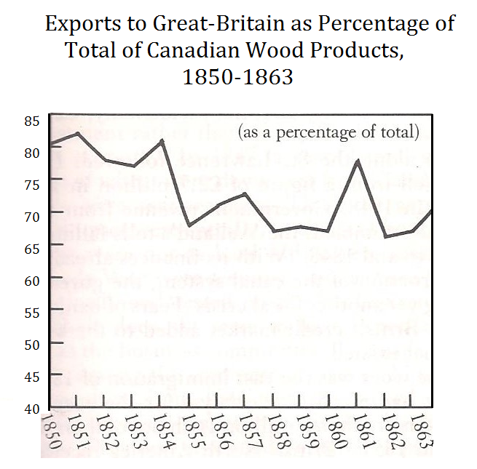

*Figure 5: Canada’s Exports, 1850-1863*

*Source:* from Kenneth Norrie and Douglas Owram, *A History of the Canadian Economy* (Toronto: Harcourt Brace Jovanovich, 1991), 210-211

Of course, the end of the British preferential system implied that Canadians could not rely on one market anymore. That said, Great Britain was still, by far, the biggest consumer of Canadian products: Great Britain’s share in Canadian exports accounted for 70 to 80 percent, with the United States taking the rest. More and more Canadian merchants, however, were looking to their southern neighbours, which led to the Reciprocity Treaty of 1854.

**The Reciprocity Treaty**

The Reciprocity Treaty of 1854 between the Province of Canada, the Maritime colonies, and the United States of America brought a mutual reduction of customs duties charged for both American and Canadian products exchanged between the two countries. Although the Americans were not interested in such an agreement at first, the promised access to Canadian waters they received gave them an incentive to sign the treaty. Both Great Britain and America disputed the access to Canadian waters, and a conflict was barely avoided in 1852 when both countries sent ships to protect their fishermen.[45] In order to make the United States sign the Treaty in 1854, British North America knew it had to include fishing rights, and, with the support of Great Britain, eager to avoid a diplomatic incident[46], did so – ignoring the protests of the Atlantic colonies which weren’t inclined to their inclusion in the treaty. Nova Scotia, in particular, was pressured into accepting the treaty, as Britain threatened to withdraw its patrol boats, making American encroachment unavoidable.[47] The Reciprocity Treaty, in total, accounts for approximately 90 percent of the items traded between British North America and the United States[48], and constitutes a major contribution to the economic growth of the colonies since 1854; between 1854 and 1855, the shipments of items (mainly grains, breadstuff, animal products, fish, timber and minerals[49]) covered by the treaty increased by 96%[50]; even in the weakest years, they were 50% above their pre-treaty levels, and have soared since the beginning of the Civil War.[51] However, growing resentment among American producers currently results in a mounting pressure on the government of the U.S.A to abrogate the Treaty.

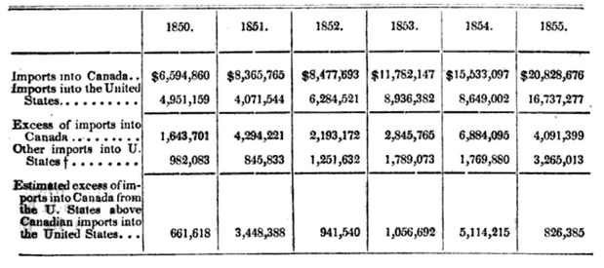

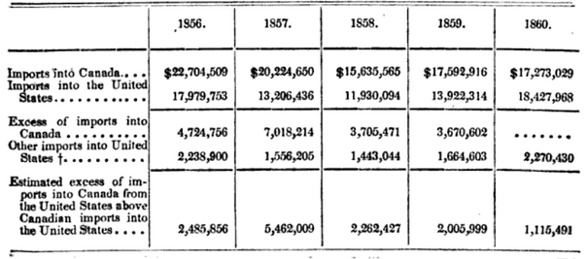

*Figure 6: Imports and Exports to and from the United States and Canada from December 31, 1839 to January 1, 1861*

Source: *Report of the Minister of Finance on the Reciprocity Treaty with the United States*, printed by order of his Excellency the Governor General (Stewart Derbishire and George Desbarats, Quebec, 1862), 51

**Industrialization**

The European Industrial Revolution, which started in Great Britain, soon came to the United States and Canada, and its effects were clearly demonstrated in the area of land-based transportation. Distances and weather made that mode of transportation frighteningly expensive and incited the Canadian Government to focus more on state-sponsored canals. Canada waited until 1849 to pass the Railway Loan Guarantee Act[52] which ushered the colony into “rail fever”. Between 1849 and 1859, the year that saw the end of the construction of the Grand Trunk Railway, between Quebec City and Sarnia, the province of Canada had gone from 66 to 1800 miles of railways. This new rail network, however, did not generate enough revenues to bear its operating cost, or its capital investment[53], leading to a crisis in 1857-1858.[54] Nonetheless, they propelled urban centres like Montreal and Toronto to dominate other, smaller cities.[55] However, railways supplemented rather than supplanted the cheaper waterway transportation.[56] After the Grand Trunk, railways were constructed much more cautiously. In 1859, 520 miles were opened: this figure shifted to 44 in 1860, 9 in 1861, and ultimately 0 in 1862.[57]

Along with the growth of the heavy industry came demands for protectionist measures. In 1859, the Galt-Cayley Tariff protected a significant range of manufacturers from foreign competition, mostly American.[58]Railways and industrialization brought three major developments.[59] First, Canada West is experiencing a major economic shift from the primary sector to the secondary one. This population growth (from 2.4 million to 3.2 million between 1851 and 1861[60]) and ensuing manufacturing boom is progressively reducing the amount of good crown land available for settlement west of Canada East, leading Canada West to progressively become more reliant on wheat importation. Secondly, the railways have created a need for a broader financial base for the government, which still has to be addressed. Thirdly, the Province of Canada has begun to seek ways to break out from the St-Lawrence valley and continue westward its extensive growth, something which can only be achieved through new political arrangements.

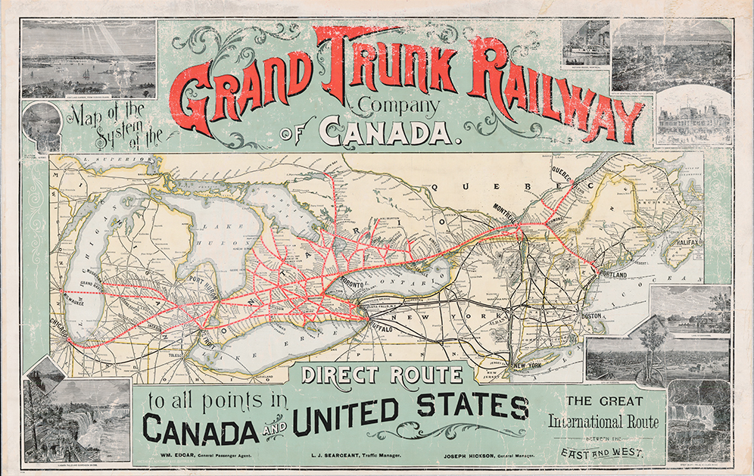

*Figure 7: Grand Trunk Railways in the Province of Canada*

**La Colonie de la Rivière Rouge (*Red River Colony*)**

La Colonie de la Rivière Rouge est un projet de colonie créé en 1811 à partir de territoires concédés par la Compagnie de la Baie d’Hudson, à l’ouest de la Province du Canada et au nord du territoire du Minnesota établi en 1849[61]. La Baie d’Hudson établit rapidement un monopole sur les territoires aux dépens des Métis, peuple de ces territoires et des trappeurs, protégée par *The Charter and the Exclusive License to Trade*[62]*.* Mais la disparition progressive des bisons, la concurrence entre la Baie d’Hudson et la *American Fur Company* depuis les années 1840[63], le procès de Sayer en 1849[64] où les Métis refusèrent tout recours légal à *The Charter* pour justifier le monopole, et l’influence grandissante du territoire du Minnesota dans le commerce avec les trappeurs[65] fit en sorte que le monopole de la Compagnie de la Baie d’Hudson s’écroula dès le début des années 1850. De ce fait, la Colonie de la Rivière Rougese trouva, et se trouve encore en 1864, dans une période de transition, où elle oscille entre les États-Unis et le Canada, qui cherchent toujours de nouvelles terres pour s’étendre. Le Canada en particulier regardant avidement vers l’ouest. L’attraction vers les États-Unis, d’abord commerciale, est extrêmement puissante avant 1861; dès 1859, la Compagnie de la Baie d’Hudson privilégie la voie maritime des États-Unis, et non celle de la Baie, pour commercer la Colonie de la Rivière Rouge[66]: le territoire du Minnesota, avec lequel les contacts sont très fréquents, avait en 1860 une population plus importante que celle de la Rivière Rouge. Cependant, la guerre civile de 1861 et une révolte Sioux dans le nord du Minnesota en 1862[67] ralentirent la plus que probable annexion de la colonie par les États-Unis, et offrent encore aujourd’hui au Canada l’opportunité de rallier cette dernière à sa cause. Cette colonie est un possible point de conflit entre le Canada et les États-Unis, car elle est vue comme essentielle aux deux pour leur expansion.  Cependant, les Métis grondent et veulent éviter le plus possible un retour à une situation similaire à celle vécue sous le monopole coercitif de la Compagnie de la Baie d’Hudson.

**Les colonies atlantiques**

Les colonies atlantiques forment encore aujourd’hui un ensemble à part. Alors que la Province du Canada se sépare entre deux entités distinctes, Canada-Ouest et Canada-Est, les provinces atlantiques de Terre-Neuve, l’Île-du-Prince-Édouard, la Nouvelle-Écosse et le Nouveau-Brunswick partagent des traits et des intérêts similaires et ont souvent formé un front commun, notamment dans les années 1850 et le début des années 1860. En effet, elles sont des colonies britanniques bien implantées et prospères, mais dont l’influence déclinante leur a progressivement fait prendre conscience de leur faiblesse. En effet, il est utile de rappeler ici la pression exercée par la Grande-Bretagne et la Province du Canada voisine sur la Nouvelle-Écosse pour la forcer à accepter le Traité de Réciprocité ; les protestations du reste des colonies ont été tout simplement ignorées.

Les forces des colonies maritimes, la pêche et la construction navale, n’ont pas été affectées par l’abandon du mercantilisme par la métropole britannique ; en fait, sûres de leur stabilité économique, le Nouveau-Brunswick, la Nouvelle-Écosse et l’Île-du-Prince-Édouard ont entre 1849 et 1850 approché les États-Unis pour leur proposer un partenariat de libre-échange[68], avant de se rendre compte que les Américains désiraient avoir accès à leurs eaux. Cette année, en 1864, les colonies maritimes connaissent d’ailleurs un pic dans la construction de bateaux avec 586 vaisseaux construits jusqu’à maintenant[69].

Malheureusement, les maritimes ont aussi amassé une dette considérable à cause d’une construction de chemins de fer trop étendue et dispendieuse, et ce, même si les provinces n’ont pour le moment qu’un réseau ferroviaire de 400 miles, ne les liant ni au Canada ni aux États-Unis[70]. De plus les commerçants, contrairement à leurs collègues canadiens, s’opposent fermement aux mesures protectionnistes ralentissent l’industrialisation dans les maritimes. Malgré tout, Saint-Jean est devenu un centre manufacturier important dès 1850 ; le Nouveau-Brunswick observe encore aujourd’hui des niveaux de production croissants qui, si la tendance se maintient, rivaliseront avec ceux du Canada Est dans une dizaine d’années[71]. C’est dans cette optique de croissance économique, de libre-échange et d’industrialisation que les provinces maritimes se réunissent actuellement avec en tête une union économique.

**Questions to Consider:**

1. **Le libre-échange est-il source de prospérité ou de problèmes ? Qui sera votre principal partenaire économique à l’avenir ?**
2. **How important is local control of economic decision-making and who should bear the burden of growing debt in the colonies?**
3. **Comment tenir compte des divergences entre le Canada et les colonies atlantiques, que ce soit au niveau de leurs structures et conjonctures économiques ou de leurs positions différentes sur la plupart des sujets ?­­­­­**
4. **La Colonie de la Rivière Rouge, si importante pour d’hypothétiques besoins ou impératifs économiques, sera-t-elle le terrain d’une future expansion canadienne ou deviendra-t-elle un autre état américain ?**
5. **How will the colonies be linked to one another?**

**Topic 3: Foreign Policy and Protecting our Borders**

After Abraham Lincoln was elected president on March 4th, 1861, many Southern states chose to leave the United States and ultimately declared the foundation of another federal government known as The Confederate States of America. The American Civil War erupted due to unbending differences between the free states and slave states over the power of the national government to prohibit slavery (in the territories that had not yet become states).[72] Initially, British North America was largely opposed to slavery. Nevertheless, as the war went on, popular perceptions witnessed an overwhelming shift. The economic difficulties brought on by the conflict and the constant fear of a potential American attack at any moment (followed by imminent annexation) were becoming more and more prevalent. Doubts began rising concerning the North’s intentions, which may not have been to abolish slavery after all, but instead to demolish the South. Attitudes began to change in British North America and we start to see a growing sympathy for the South.[73] A Confederate victory became a safer option and would be a more favourable environment to ensure independence.

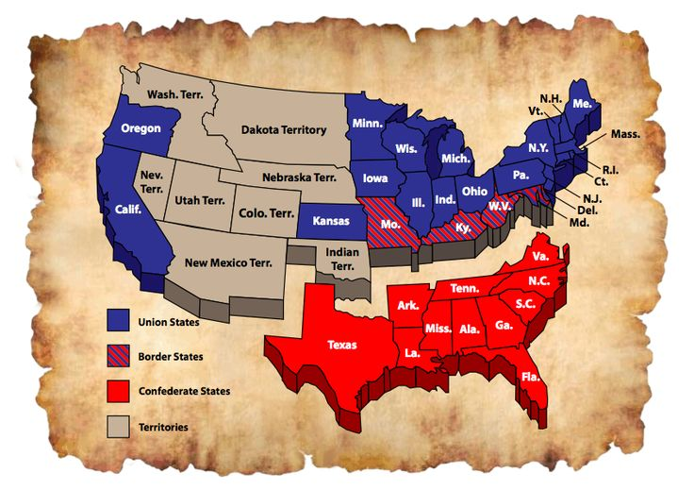

*Figure 8: Les États-Unis pendant la Guerre Civile*

**The Trent Affair**

On November 8th, 1861, a United States naval vessel (the USS Jacinto) was given information that two Confederate diplomats were on a British ship, as they were attempting to build stronger ties and become recognized by Britain (and to lobby for possible financial and military support). The American vessel thus intercepted it at sea, boarded it and took the Southerners as prisoners.[74] A burst of diplomatic and military activity ensued, and Halifax saw its military contingent increase to over 14,000.[75] This crisis went on for multiple weeks, where tensions reached a new high between the Northern states and British North America. Ignoring the popular support for an even more provocative movement, President Lincoln chose to avoid a potential war with Britain, as taking on both the English and the South simultaneously would result in absolute defeat, as other countries would be very likely to follow the lead of their British counterparts. President Lincoln decided to thus release the envoys, without issuing a formal apology.[76] Britain began to realize the primordial importance of a Canadian union, which would relieve them from constantly having to provide defensive resources to the colony.

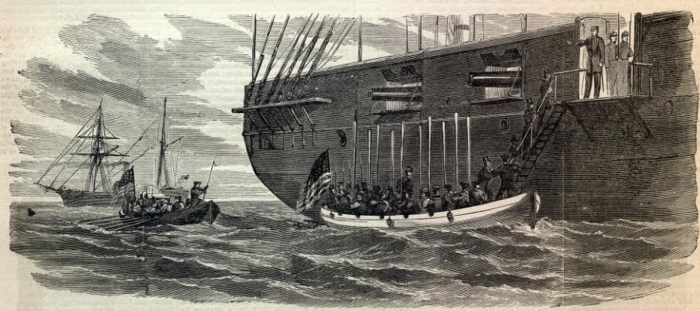

*Figure 9: Depiction of the Trent Affair*

**The Chesapeake Affair**

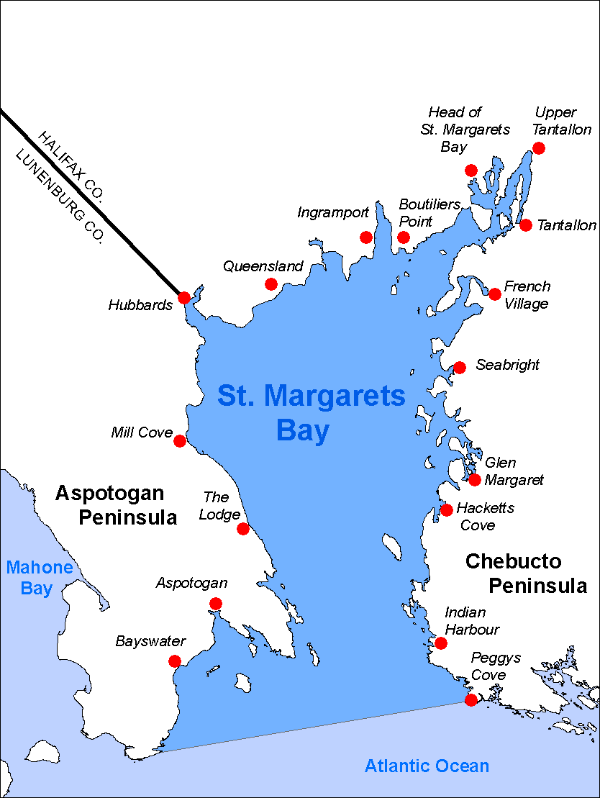 Le 7 décembre 1863, un groupe de Confédérés s'empare du navire Chesapeake lors de son parcours de New York vers Portland. Ils arrivent aux eaux territoriales britanniques à proximité du Nouveau-Brunswick et de la Nouvelle-Écosse[77]. Les passagers ont prétendu être des membres du Nord, afin de pouvoir prendre contrôle du vaisseau. La confédération a vu sa première victime dans les eaux bordant la Nouvelle-Angleterre lorsque l’un des ingénieurs à bord a été tué[78]. D’après le témoignage des prisonniers, ils ont été informés par les pirates que la grande majorité de la planification concernant l’expédition s’est produite au Nouveau-Brunswick[79]. Le groupe désirait vendre la cargaison dans les Maritimes afin de se procurer des armes, et donc transformer le Chesapeake en navire corsaire dans le but d’attaquer les navires commerçants du Nord[80]. Ces intentions n’ont guère porté fruit, car le 16 décembre 1863, deux navires menés par le Nord réussissent à reprendre contrôle du Chesapeake dans la région de la Nouvelle-Écosse. Dans l’espoir de trouver d’autres fugitifs originaires du Nord, les navires continuent leur expédition dans les eaux territoriales britanniques, ce qui enfreint la position de neutralité de Londres. Dans ce même incident, les Unionistes et les Confédérés ont tous deux mêlé les Anglais dans leur conflit[81].

*Figure 9: St. Margarets Bay, Nova Scotia – site of many of the events of the Chesapeake Affair*

**The St. Alban Raids**

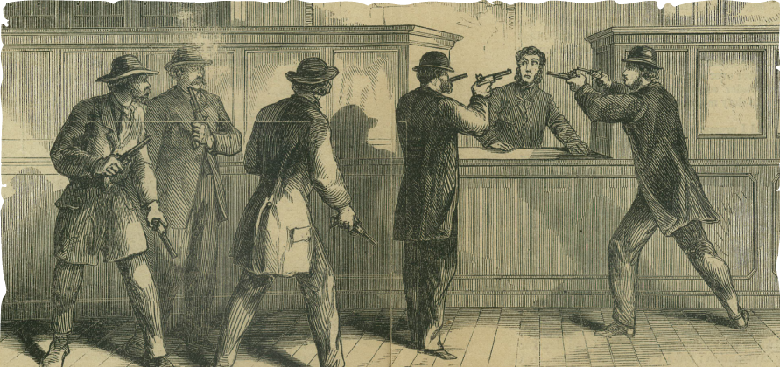

*Figure 10: Dépiction des Vol de Banques pendent les Raids de St-Alban*

In order to better understand the neutrality laws put in place on British territories, one must certainly point back to the most controversial incident involving British North America during the American Civil War. On October 19th, 1864, a gathering of Southern agents decided to disguise themselves in civilian gear (posing as Canadians to be more precise)[82], and entered three different banks in St. Albans (Vermont). All three banks were subsequently robbed and the loot acquired totalled nearly $200,000.[83] The Confederate agents fled north across the Canadian border to a secret base established in the city of Montreal.[84]

Prior to these incidents, rumours surrounding such occurrences were taking place in the city, and this led the authorities in the region to place heavier surveillance agents in the area in order to potentially prevent such actions. The investigation unfortunately did not succeed in catching the perpetrators in a timely manner.[85] The government did nevertheless step up its effort after realizing that the raiders had returned within their borders, and apprehended them in consequence. The money was retrieved and returned to their rightful proprietors; however, the immediate reaction in the United States was to send troops across the border and thus, by taking matters into their own hands, testing Canadian neutrality laws once again. Their intentions were to annihilate the Confederate agents at all costs. Once again, President Lincoln wisely chose to halt such action by refusing to invade, as this would be a direct declaration of war to Britain, which would have been catastrophic for the Unionist North. The British became once again increasingly aware of the potential of an American invasion and mostly served in favour of the Southerners, who were the main instigators.[86] It is, however, important to note that Canadians, who had been highly sympathetic to the South’s cause during the war, witnessed a shift in their initial sentiment in the aftermath of this incident. The events in St. Albans demonstrated, in British North America’s perspective, an abuse of hospitality by the Confederates on British grounds.[87]

**British North America’s Armed Forces**

During the mid-19th century, the waters surrounding the colony became the main focal points of the British North America army. The Royal Navy played a key role in protecting the Canadian shores, regardless of the relatively rare appearance of warships. The threat of a naval blockade and raids by the British fleet helped ensure diplomatic relations for the most part with their American counterparts.[88] Some main locations where the military reserves were implemented include Montreal, Halifax and Toronto.[89] Fortified bases were influential and imposing, and ultimately saw little challenges during the year.

          As the American Civil War became more concerning to locals who felt unprotected, volunteer-based Canadian militias began to be formed. More specifically, a large number of railroad employees and individuals living near railways became wary of the possible risk to such infrastructure with the war. The Grand Trunk Railway Brigade was thus formed, along with other infantry groups in order to help protect these key transport points.[90]

         In 1864-65, special military schools and colleges opened in six Canadian cities in order to train militia officers, which were run by the British garrison’s professional soldiers.[91] There was a need for more defenses, recognized by the British officials, who also hoped to keep the number of soldiers sent to the colony at a necessary minimum.

      New Brunswick and Prince Edward Island lacked a strong British garrison during the mid-19th century to inspire the local creation of militias.[92] Nevertheless, volunteers were present all over the country, but were more effective in regions that included a main focal point revolving around a British army base. The Aboriginal peoples to the west of the Province of Canada were strong fighters during the 19th century; they used bows and javelins, carried clubs and bone-bladed daggers, and could wear wooden armour.[93] They remained secluded from the important fields in play, but were mainly focused on the vulnerable areas in the Pacific.

        In general, the state of the armed forces in British North America in 1864 was limited to voluntary presence, with many Canadians having to enlist in order to assist in growing the transitory numbers. However, those fighting were very able and demonstrated great resilience and determination. It must also be noted that 33,000 to 55,000 men had decided to partake in the Civil War south of the border, thus decreasing the number of fighting men available in the colony. Britain, on their part, has recently expressed a willingness to dramatically reduce, if not completely cut off, military spending in British North America.[94]

**British North America’s Relationship with First Nations People**

D’une certaine façon, la *Proclamation royale* de 1763 était la première loi concernant l’immigration dans l’histoire du Canada. Plus spécifiquement, la *Proclamation* a mis en place des limites sur la prise de territoire et l’établissement des Européens sur les terrains occupés par les autochtones [95]. Au moment de déclarer la victoire suite à la guerre des Sept Ans, le roi George III prend officiellement contrôle du territoire. Malgré cela, la *Proclamation* clarifie que les groupes autochtones auront priorité sur les terrains qui sont déjà sous leur contrôle.

In other words, a procedure was set out in order to facilitate British-Indian relations by providing Aboriginal peoples with the power to choose whether or not to sell their lands to the British Crown[96]. It is only after this act that settlers may then purchase the land from British authorities. The proclamation explicitly forbids newly arrived migrants from claiming Native lands.[97] It also defined the land to the west of established colonies as "Indian Territories", where Aboriginal people "should not be molested or disturbed" by settlers. The Indian Department would be the main link between the Crown and First Nations individuals (primarily landowners).[98]

However, it is important to note the lack of recognition and enforcement of Aboriginal rights which has taken place on North American territory, regardless of the *Royal Proclamation*. First Nations peoples have consistently been undervalued and mistreated, regardless of their many accomplishments. During the War of 1812, thousands of First Nations warriors and Métis fighters fought alongside the British army and Canadian settler militias in order to prevent American expansion up north.[99] These fighters were instrumental in resulting victories such as the Battle of Châteauguay.[100] Despite this somewhat cordial relationship, the peace and friendship treaties that used to be the norm have now been replaced by land transfer agreements.[101] In fact, more than 110 treaties and surrenders of land have been signed between British North America and Aboriginal peoples since the conquest, mainly in order to ensure economic development and increase available land mass for new settlers.[102] Of note, most of these land transfer agreements were signed during the nineteenth century, in an era where the Colonial Office was starting to delegate responsibility for Aboriginal policy to colonial authorities.[103]

Their very survival is at times threatened. As Abraham Gesner, the Indian Commissioner for Nova Scotia noted in the late 1840s: “In return for the lands for which they were the rightful owners, they have received loathsome diseases, alcoholic drink, the destruction of their game, and threatened extermination.”[104] The best example being that of the Beothuk who, because of European settlement near the coast of Newfoundland, had been pushed into the interior, where their living conditions remained problematic until their complete disappearance in 1829.[105] Aboriginal peoples have been cooperating with colonists in large numbers – both to ensure their survival and that of their neighbours during times of conflict; nonetheless, their value remains unaccounted for and their status up to this date is largely ignored.

**Questions to Consider:**

1. **Quel devrait être le rôle de l’Amérique du Nord britannique dans l’Empire britannique ?**
2. **How should British North America adapt to a reduction in British military spending? Who is best placed to support the financial cost necessary to continue these investments?**
3. **How will other colonies or territories be admitted into the union?**
4. **Should the relationship with Aboriginal peoples change and who will be tasked with managing it? How can British North America expand West in these circumstances?**

**Bibliography**

# “17th Amendment to the U.S. Constitution: Direct Election of U.S. Senators”. (n.d.). In *National Archives*,Retrieved from https://www.archives.gov/legislative/features/17th-amendment/.

“250th Anniversary of the Royal Proclamation of 1763”. (2013). In *Indigenous and Northern Affairs Canada*, Retrieved from <https://www.aadnc-aandc.gc.ca/eng/1370355181092/1370355203645>.

“Aboriginal Contributions to the War of 1812: Theatres of War Map”. (2012). In *Indigenous and Northern Affairs Canada*, Retrieved from <http://www.aadnc-aandc.gc.ca/eng/1338906996435/1338907038331>.

“About the Supreme Court”. (n.d.). In *United States Court*,Retrieved from <http://www.uscourts.gov/about-federal-courts/educational-resources/about-educational-outreach/activity-resources/about>.

*Acte concernant la Cour du Banc de la Reine*, SRBC 1861, c 76.

“Act of Union”. (2015). In *Canadian Encyclopedia*,Retrieved from <http://www.thecanadianencyclopedia.ca/en/article/act-of-union/>.

*An Act Respecting the Courts of Chancery*, SUC 1859, c 12.

*An Act Respecting the Qualifications, Appointment and Tenure of Office of the Principal Judicial Officers,* RSNS 1864, c 37.

*An Act Respecting the Superior Courts of Civil and Criminal Jurisdiction*, SUC 1859, c 10.

*An Act Respecting the Supreme Court and its Offices*, RSNS 1864, c 123.

“Bicameralism: Legislature with Two Chambers”. (2014). In *Constitution Net,* Retrieved from <http://www.constitutionnet.org/files/bicameralism_0.pdf>.

Boyko, John. “Canadians for the Confederacy”. *National Post*, July 5, 2013. <http://news.nationalpost.com/full-comment/john-boyko-canadians-for-the-confederacy>.

“Cabinet”. (2016). In *Historica Canada*, Retrieved from <http://www.thecanadianencyclopedia.ca/en/article/cabinet/>.

“Canadian Military History Gateway”. (n.d.), In *Government of Canada*, Retrieved from <http://www.cmhg.gc.ca/html/tl-tc/index->eng.asp?N=20001+1864&subject=100250&Num=&RT=&yr=1864&ss=1&c=1800&d=1860.

*Colonial Laws Validity Act,* 1865(UK), 28 & 29 Vict, c 63.

“Confederation: Introduction”. (n.d.). In *Canadian History Project*, Retrieved from <http://www.canadahistoryproject.ca/1867/>.

Conrad, Margaret R. & James K. Hiller. *Atlantic Canada: A History.* Don Mills: Oxford University Press, 2010.

“Courts of Law”. (2013). In *Historica Canada,* Retrieved from <http://www.thecanadianencyclopedia.ca/en/article/courts-of-law/>.

Couturier, Jacques Paul. *Un passé composé : Le Canada de 1850 à nos jours.* Moncton :Les Éditions d’Acadie, 2000.

Dickason, Olive Patricia. *Canada’s First Nations: A* *History of Founding Peoples from Earliest Times.* Toronto: The Canadian Publishers, 1992.

“Distribution of the British Army: 2 April 1864”. (1994). In *GFN*, Retrieved from <http://www.cgsc.edu/CARL/nafziger/864DAA%20(2).pdf>.

Eicher, David J. “Confederacy”. *Civil War Times* *Magazine*, 2008. <http://www.historynet.com/confederacy>.

“Great Coalition”. (2015). In *Historica Canada*, Retrieved from <http://www.thecanadianencyclopedia.ca/en/article/great-coalition/>.

House of Lords. (2011). In *UK Parliament,* Retrieved from http://www.parliament.uk/documents/lords-information-office/HoLwhat-the-lords-and-its-members-do-v2.pdf.

“Incidence de la guerre de Sécession”. (2016). In *Bibliothèque et Archives Canada*, Retrieved from <http://www.bac-lac.gc.ca/fra/decouvrez/politique-gouvernement/confederation-canadienne/Pages/incidence-guerre-secession.aspx#d>.

*Judicial Committee Act*, 1833, 3 & 4 Wm IV, c 41.

*Judicial Committee Act*, 1844, 7 & 8 Vict, c 69.

Lewis, Thomas T., ed., *The Bill of Rights.* Pasadena, California: Salem Press Inc., 2002.

Marquis, Greg. *In Armageddon's Shadow: The Civil War and Canada's Maritime Provinces*. Halifax: McGill-Queen's University Press, 1998.

“Maritime Union”. (2001). In *Library and Archives Canada,* Retrieved from <https://www.collectionscanada.gc.ca/confederation/023001-3010.33-e.html>.

McCallum, John. *Unequal Beginnings: Agricultural and Economic Development in Quebec and Ontario until 1870.* Toronto: University of Toronto Press, 1980.

“Membership of the House of Lords”. (n.d.). In *UK Parliament*,Retrieved from https://www.parliament.uk/about/mps-and-lords/about-lords/lords-types/.

Michele Costi, Angelo. *Memoir of the Trent Affair* (Washington: McGill & Witherow Printers and Stereotypers, 1865).

Minville, Esdras. *Histoire Économique du Canada.* Montréal : Librairie Beauchemin Limitée.

Monahan, Patrick J. and Byron Shaw. *Constitutional Law*. Toronto: Irwin Law, 2013.

*Nadan v The King (Alberta)*, [1926] UKPC 13.

Nerenberg, Karl and Ann L. Griffiths, *Guide des pays fédéreés*. Montreal: McGill-Queen's University Press, 2002.

“Newfoundland, Pre-1864”. (2005). In *Library and Archives Canada,* Retrieved from <https://www.collectionscanada.gc.ca/confederation/023001-3060-e.html#b>.

Norrie, Kenneth & Douglas Owram, *A History of the Canadian Economy.* Toronto: Harcourt Brace Jovanovich, 1991.

O’Brien, Audrey & Marc Bosc, ed., *House of Commons Procedure and Practice*. Québec: Éditions Yvon Blais, 2009.

Officer, Lawrence & Lawrence Smith, “The Canadian American Reciprocity Treaty of 1855 to 1868”, *Journal of Economic History* 28 (December 1968).

“Parliamentary Sovereignty”. (n.d.). In *UK Parliament*, Retrieved from <https://www.parliament.uk/about/how/role/sovereignty/>.

“Provinces and Territories”. (2005). In *Library and Archives Canada*, Retrieved from <https://www.collectionscanada.gc.ca/confederation/023001-3100-e.html>.

“Réciprocité”. (2015). In *Historica Canada*, Retrieved from <http://www.thecanadianencyclopedia.ca/fr/article/reciprocite/>.

“Responsible Government”. (2015). In *Canadian Encyclopedia*,Retrieved from <http://www.thecanadianencyclopedia.ca/en/article/responsible-government/>.

Richardson, Jessica. “Modernisation of Royal Assent in Canada”, *Canadian Parliamentary Review* 27 (2004).

“Royal Proclamation, 1763”. (n.d.), In *Indigenous Foundations,* Retrieved from <http://indigenousfoundations.arts.ubc.ca/home/government-policy/royal-proclamation-1763.html>.

“The 1832 Reform Act”. (n.d). In *British Library*,Retrieved from http://www.bl.uk/learning/histcitizen/21cc/struggle/chartists1/historicalsources/source2/reformact.html.

“The Beothuk”. (1997). In *Heritage Newfoundland & Labrador*, Retrieved from <http://www.heritage.nf.ca/articles/aboriginal/beothuk.php>.

“The Confederation Conference, 1864”. (2005). In *Library and Archives Canada*,Retrieved from <https://www.collectionscanada.gc.ca/confederation/023001-3060-e.html>.

“The Royal Military College of Canada: 1876 to the Present Dispatches: Backgrounders in Canadian Military History”. (n.d.). In *Canadian War Museum*, Retrieved from <http://www.warmuseum.ca/learn/dispatches/the-royal-military-college-of-canada-1876-to-the-present/#tabs>.

“The Royal Proclamation of 1763, The Quebec Act of 1774”. (2013). In *Historical Narratives of Early Canada*, Retrieved from http://www.uppercanadahistory.ca/pp/ppa.html.

*The Union Act,* 1840 (UK), 3 & 4 Vict, c 35.

“US Civil War”. (2013). In *Canada History*, Retrieved from http://www.canadahistory.com/sections/eras/confederation/US.html.

Winks, Robin W. *Civil War Years: Canada and the United States*. Montréal: McGill-Queen's University Press, 2014.

1. Audrey O’Brien & Marc Bosc, ed., *House of Commons Procedure and Practice* (Québec: Éditions Yvon Blais, 2009), 4.
2. Patrick J. Monahan and Byron Shaw. *Constitutional Law* (Toronto: Irwin Law, 2013), 35-37.
3. O’Brien & Bosc, 10-11.
4. *Ibid*, 37-41.
5. “Act of Union”. (2015). In *Canadian Encyclopedia*,Retrieved from <http://www.thecanadianencyclopedia.ca/en/article/act-of-union/>.
6. *Ibid.*
7. Monahan & Shaw, 41-46; “Provinces and Territories”. (2005). In *Library and Archives Canada*, Retrieved from <https://www.collectionscanada.gc.ca/confederation/023001-3100-e.html>.
8. “Responsible Government”. (2015). In *Canadian Encyclopedia*,Retrieved from <http://www.thecanadianencyclopedia.ca/en/article/responsible-government/>.
9. O’Brien & Bosc, 12.
10. Monahan & Shaw, 47.
11. *Ibid.*
12. Monahan & Shaw, 47-49.
13. “Great Coalition”. (2015). In *Historica Canada*, Retrieved from <http://www.thecanadianencyclopedia.ca/en/article/great-coalition/>.
14. “Confederation: Introduction”. (n.d.). In *Canadian History Project*, Retrieved from <http://www.canadahistoryproject.ca/1867/>.
15. Conrad, Margaret R. & James K. Hiller. *Atlantic Canada: A History* (Don Mills: Oxford University Press, 2010), 135.
16. “Maritime Union”. (2001). In *Library and Archives Canada,* Retrieved from <https://www.collectionscanada.gc.ca/confederation/023001-3010.33-e.html>.
17. “Newfoundland, Pre-1864”. (2005). In *Library and Archives Canada,* Retrieved from <https://www.collectionscanada.gc.ca/confederation/023001-3060-e.html#b>.
18. Conrad & Hiller, 137.
19. “The Confederation Conference, 1864”. (2005). In *Library and Archives Canada*,Retrieved from <https://www.collectionscanada.gc.ca/confederation/023001-3060-e.html>.
20. *The Union Act,* 1840 (UK), 3 & 4 Vict, c 35, s LXI; O’Brien & Bosc, 11-12.
21. Monahan & Shaw, 47.
22. O’Brien & Bosc, 3; “Cabinet”. (2016). In *Historica Canada*, Retrieved from <http://www.thecanadianencyclopedia.ca/en/article/cabinet/>.
23. “Bicameralism: Legislature with Two Chambers”. (2014). In *Constitution Net,* Retrieved from <http://www.constitutionnet.org/files/bicameralism_0.pdf>.
24. Jessica Richardson, “Modernisation of Royal Assent in Canada”, *Canadian Parliamentary Review* 27 (2004): 32-36.
25. *The Union Act,* 1840 (UK), 3 & 4 Vict, c 35, s LVII.
26. O’Brien & Bosc, 8.
27. *Colonial Laws Validity Act,* 1865(UK), 28 & 29 Vict, c 63.
28. “Courts of Law”. (2013). In *Historica Canada,* Retrieved from <http://www.thecanadianencyclopedia.ca/en/article/courts-of-law/>.
29. See for example: *An Act Respecting the Qualifications, Appointment and Tenure of Office of the Principal Judicial Officers,* RSNS 1864, c 37; *An Act Respecting the Supreme Court and its Offices*, RSNS 1864, c 123; *An Act Respecting the Superior Courts of Civil and Criminal Jurisdiction*, SUC 1859, c 10; *An Act Respecting the Courts of Chancery*, SUC 1859, c 12; *Acte concernant la Cour du Banc de la Reine*, SRBC 1861, c 76.
30. *Judicial Committee Act*, 1833, 3 & 4 Wm IV, c 41; *Judicial Committee Act*, 1844, 7 & 8 Vict, c 69; *Nadan v The King (Alberta)*, [1926] UKPC 13.
31. Thomas T. Lewis, *The Bill of Rights* (Pasadena, California: Salem Press Inc., 2002), 36.
32. Sandford Schram, “Les États-Unis d’Amérique”in Karl Nerenberg and Ann L. Griffiths, *Guide des pays fédéreés* (Montreal: McGill-Queen's University Press, 2002), 202-203.
33. # “17th Amendment to the U.S. Constitution: Direct Election of U.S. Senators”. (n.d.). In *National Archives*,Retrieved from

    https://www.archives.gov/legislative/features/17th-amendment/.
34. “About the Supreme Court”. (n.d.). In *United States Court*,Retrieved from http://www.uscourts.gov/about-federal-courts/educational-resources/about-educational-outreach/activity-resources/about.
35. “Membership of the House of Lords”. (n.d.). In *UK Parliament*,Retrieved from https://www.parliament.uk/about/mps-and-lords/about-lords/lords-types/.
36. “The 1832 Reform Act”. (n.d). In *British Library*,Retrieved from http://www.bl.uk/learning/histcitizen/21cc/struggle/chartists1/historicalsources/source2/reformact.html.
37. “House of Lords”. (2011). In *UK Parliament,* Retrieved from http://www.parliament.uk/documents/lords-information-office/HoLwhat-the-lords-and-its-members-do-v2.pdf.
38. “Parliamentary Sovereignty”. (n.d.). In *UK Parliament*, Retrieved from https://www.parliament.uk/about/how/role/sovereignty/.
39. Kenneth Norrie & Douglas Owram, *A History of the Canadian Economy* (Toronto: Harcourt Brace Jovanovich, 1991), 207.
40. Esdras Minville, *Histoire Économique du Canada* (Montréal : Librairie Beauchemin Limitée), 102.
41. Norrie & Owram, 207.
42. *Ibid.*
43. *Ibid.*
44. John McCallum, *Unequal Beginnings: Agricultural and Economic Development in Quebec and Ontario until 1870* (Toronto: University of Toronto Press, 1980), 124, 127, 216.
45. “Réciprocité”. (2015). In *Historica Canada*, Retrieved from http://www.thecanadianencyclopedia.ca/fr/article/reciprocite/.
46. Norrie & Owram, 217.
47. *Ibid.*
48. *Ibid.*
49. Norrie & Owram, 218.
50. Lawrence Officer & Lawrence Smith, “The Canadian American Reciprocity Treaty of 1855 to 1868”, *Journal of Economic History* 28 (December 1968), 600.
51. *Ibid.*
52. Norrie & Owram, 226.
53. *Ibid.*
54. Minville, 116.
55. Norrie & Owram, 229.
56. *Ibid,* 230.
57. Officer & Smith, 603, 609.
58. Norrie & Owram, 238.
59. *Ibid,* 240-241.
60. *Ibid,* 276.
61. Norrie & Owram, 276.
62. *Ibid,* 276.
63. *Ibid,* 269.
64. *Ibid,* 268.
65. *Ibid,* 268.
66. *Ibid.*
67. *Ibid.*
68. Norrie & Owram*,* 216
69. *Ibid,* 214
70. *Ibid,* 232
71. *Ibid,* 239
72. David J. Eicher, “Confederacy”. *Civil War Times* *Magazine*, 2008. <http://www.historynet.com/confederacy>.
73. John Boyko, “Canadians for the Confederacy”. *National Post*, July 5, 2013. <http://news.nationalpost.com/full-comment/john-boyko-canadians-for-the-confederacy>.
74. “US Civil War”. (2013). In *Canada History*, Retrieved from http://www.canadahistory.com/sections/eras/confederation/US.html.
75. “Incidence de la guerre de Sécession”. (2016). In *Bibliothèque et Archives Canada*, Retrieved from <http://www.bac-lac.gc.ca/fra/decouvrez/politique-gouvernement/confederation-canadienne/Pages/incidence-guerre-secession.aspx#d>.
76. Angelo Michele Costi, *Memoir of the Trent Affair* (Washington: McGill & Witherow Printers and Stereotypers, 1865).
77. “Incidence de la guerre de Sécession”. (2016).
78. Greg Marquis, *In Armageddon's Shadow: The Civil War and Canada's Maritime Provinces* (Halifax: McGill-Queen's University Press, 1998), 142.
79. *Ibid*, 145.
80. “Incidence de la guerre de Sécession”. (2016).
81. “Incidence de la guerre de Sécession”. (2016).
82. Robin W. Winks, *Civil War Years: Canada and the United States* (Montréal: McGill-Queen's University Press, 2014), 298.
83. “Incidence de la guerre de Sécession”. (2016).
84. Winks, 296.
85. Winks, 298.
86. “US Civil War”. (2013).
87. Winks, 307.
88. “Canadian Military History Gateway”. (n.d.), In *Government of Canada*, Retrieved from <http://www.cmhg.gc.ca/html/tl-tc/index->eng.asp?N=20001+1864&subject=100250&Num=&RT=&yr=1864&ss=1&c=1800&d=1860.
89. “Distribution of the British Army: 2 April 1864”. (1994). In *GFN*, Retrieved from http://www.cgsc.edu/CARL/nafziger/864DAA%20(2).pdf.
90. “Canadian Military History Gateway”.
91. “The Royal Military College of Canada: 1876 to the Present Dispatches: Backgrounders in Canadian Military History”. (n.d.). In *Canadian War Museum*, Retrieved from <http://www.warmuseum.ca/learn/dispatches/the-royal-military-college-of-canada-1876-to-the-present/#tabs>.
92. “Canadian Military History Gateway”.
93. “Canadian Military History Gateway”.
94. Jacques Paul Couturier, *Un passé composé : Le Canada de 1850 à nos jours* (Moncton : Les Éditions d’Acadie, 2000), 42.
95. “Royal Proclamation, 1763”. (n.d.), In *Indigenous Foundations,* Retrieved from <http://indigenousfoundations.arts.ubc.ca/home/government-policy/royal-proclamation-1763.html>.
96. “Royal Proclamation, 1763”; “The Royal Proclamation of 1763, The Quebec Act of 1774”. (2013). In *Historical Narratives of Early Canada*, Retrieved from http://www.uppercanadahistory.ca/pp/ppa.html.
97. “Royal Proclamation, 1763”.
98. “250th Anniversary of the Royal Proclamation of 1763”. (2013). In *Indigenous and Northern Affairs Canada*, Retrieved from https://www.aadnc-aandc.gc.ca/eng/1370355181092/1370355203645.
99. “Aboriginal Contributions to the War of 1812: Theatres of War Map”. (2012). In *Indigenous and Northern Affairs Canada*, Retrieved from <http://www.aadnc-aandc.gc.ca/eng/1338906996435/1338907038331>.
100. *Ibid*.
101. Olive Patricia Dickason, *Canada’s First Nations: A* *History of Founding Peoples from Earliest Times* (Toronto: The Canadian Publishers, 1992), 189.
102. *Ibid*, 273.
103. Conrad & Miller, 109.
104. *Ibid*.
105. *Ibid*, 109-110; “The Beothuk”. (1997). In *Heritage Newfoundland & Labrador*, Retrieved from <http://www.heritage.nf.ca/articles/aboriginal/beothuk.php>.